**Hizzle Task**

This document contains tasks for frontend and backend. Depending on the requirements, you should do either or both sections.

Feel free to use any tools to bootstrap the projects like npm, vuecli, nestcli with any configuration that is easier for you. Spending time setting up the app is not the goal here, so use whatever tools you prefer. **For frontend-only development, please use the sample JSON data that is included on the last page of this document to mock api calls.**

**Frontend - Vue.js**

You are required to build a single page with two areas to display properties and offers. Each property/offer should be presented like a card with a width between 300-600px. Exact dimensions and details like how many cards should fit per row are left up to you, what is important is that the containers for these cards should be responsive, so when viewing from a mobile client we should comfortably see one or two cards per column (depending on mobile client width - phone/tablet).

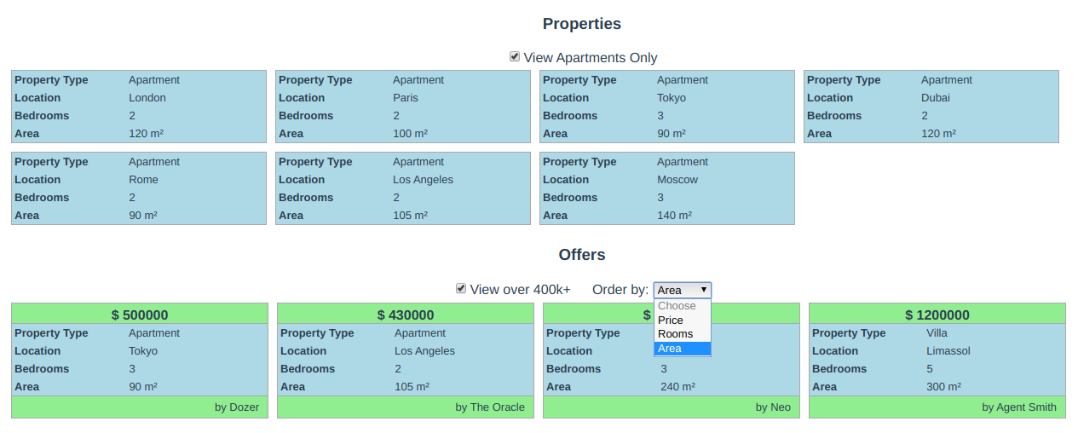

**Specifications**:

* Property cards should display Property Type, Location, Bedrooms and Area
* There should be a property filter that allows the user to view only apartments
* Offer cards should display property data as well as price and author.
* Offers should have a filter to show any offers above 400k and a select dropdown that lets the user order by price, rooms or area.

**Optional**:

* Highlight a property when a user clicks on it, and show offers only related to that property
* Improve styles to your own discretion

**Backend - NestJS**

Build a simple server in NestJS to provide the above frontend with two API endpoints:

1. GET /properties
2. GET /offers

The backend should use TypeORM to read data from a database and serve it to the frontend. Please implement the above according to the NestJS architecture (modules, controllers, services,etc.).

The endpoints should return data exactly like the sample JSON data at the end of this document. Offers contain property data as well.

You may use any TypeORM supported database.

**Delivery**

Please provide your solution in a zip file along with instructions how to set up and run the dev servers.

For any questions, feel free to send an email at [alex@thehizzle.com](mailto:alex@thehizzle.com)

**Sample JSON data**

Properties

[{"id": 1,"kind": "House","location": "New York","bedrooms": 3,"area": 240},{"id": 2,"kind": "Apartment","location": "London","bedrooms": 2,"area": 120},{"id": 3,"kind": "Apartment","location": "Paris","bedrooms": 2,"area": 100},{"id": 4,"kind": "Apartment","location": "Tokyo","bedrooms": 3,"area": 90},{"id": 5,"kind": "House","location": "Athens","bedrooms": 4,"area": 150},{"id": 6,"kind": "Studio","location": "Berlin","bedrooms": 1,"area": 70},{"id": 7,"kind": "Villa","location": "Limassol","bedrooms": 5,"area": 300},{"id": 8,"kind": "Apartment","location": "Dubai","bedrooms": 2,"area": 120},{"id": 9,"kind": "Apartment","location": "Rome","bedrooms": 2,"area": 90},{"id": 10,"kind": "Apartment","location": "Los Angeles","bedrooms": 2,"area": 105},{"id": 11,"kind": "House","location": "Barcelona","bedrooms": 3,"area": 210},{"id": 12,"kind": "Apartment","location": "Moscow","bedrooms": 3,"area": 140}]

Offers

[{"id": 1,"offered_by": "Neo","price": 400000,"property": {"id": 1,"kind": "House","location": "New York","bedrooms": 3,"area": 240}},{"id": 2,"offered_by": "Morpheus","price": 300000,"property": {"id": 3,"kind": "Apartment","location": "Paris","bedrooms": 2,"area": 100}},{"id": 3,"offered_by": "Agent Smith","price": 1200000,"property": {"id": 7,"kind": "Villa","location": "Limassol","bedrooms": 5,"area": 300}},{"id": 4,"offered_by": "Trinity","price": 250000,"property": {"id": 9,"kind": "Apartment","location": "Rome","bedrooms": 2,"area": 90}},{"id": 5,"offered_by": "The Oracle","price": 430000,"property": {"id": 10,"kind": "Apartment","location": "Los Angeles","bedrooms": 2,"area": 105}},{"id": 6,"offered_by": "Cypher","price": 340000,"property": {"id": 11,"kind": "House","location": "Barcelona","bedrooms": 3,"area": 210}},{"id": 7,"offered_by": "Apoc","price": 350000,"property": {"id": 2,"kind": "Apartment","location": "London","bedrooms": 2,"area": 120}},{"id": 8,"offered_by": "Agent Jones","price": 280000,"property": {"id": 3,"kind": "Apartment","location": "Paris","bedrooms": 2,"area": 100}},{"id": 9,"offered_by": "Tank","price": 190000,"property": {"id": 6,"kind": "Studio","location": "Berlin","bedrooms": 1,"area": 70}},{"id": 10,"offered_by": "Dozer","price": 500000,"property": {"id": 4,"kind": "Apartment","location": "Tokyo","bedrooms": 3,"area": 90}},{"id": 11,"offered_by": "Agent Brown","price": 350000,"property": {"id": 11,"kind": "House","location": "Barcelona","bedrooms": 3,"area": 210}},{"id": 12,"offered_by": "Switch","price": 320000,"property": {"id": 3,"kind": "Apartment","location": "Paris","bedrooms": 2,"area": 100}}]